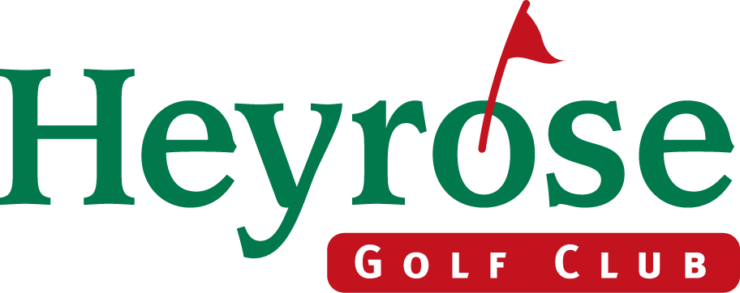

ENTRY FORM

SENIORS AUTUMN OPEN COMPETITION
4 BALL BETTER BALL STABLEFORD
FRIDAY 3RD OCTOBER 2014
Maximum Handicap: 24 (3/4 allowance). Age limit 55 & over.
Start times 9.00am – 2.00pm £12.00 per player.
___________________________________________________________________________________

Please return Completed entry form.
Cheque for £12.00 per player payable to Heyrose Golf Club.
ENCLOSING STAMPED ADDRESSED ENVELOPE

to :- Hazel March (Seniors Autumn Open Competition)
Heyrose Golf Club
Budworth Road
Tabley, Knutsford
Cheshire WA16 0HZ. Tel :- 01565 733664

Name ____________________________ Club ________________________ H/cap ______

Name ____________________________ Club ________________________ H/cap ______

Name ____________________________ Club ________________________ H/cap ______

Name ____________________________ Club ________________________ H/cap ______

Name and address for correspondence :- ______________________________________

______________________________________

______________________________________

Tel :- ____________________ ______________________________________

All winners must produce an official handicap certificate.
Meals available all day. Soft spikes preferred.
Reservations for Tee Times cannot be requested. Presentations on completion of competition.
Should this event be cancelled due to inclement weather an alternative date will be offered.
No refunds will be given.
_______________________________________________________________________

For Heyrose use - This portion will be returned to you following payment. - Senior Autumn Open Competition

Payment of £ _______ is hereby acknowledged.

You have been allocated ___________ as your tee time on Friday 3rd October 2014.
Heyrose Golf Club is situated 1 mile from junction 19 on M6 (Knutsford/Northwich turn off). Turn towards Northwich and then immediately right at The Windmill Inn. In approximately 1/2 a mile fork right at junction. Our Golf Course is about 1/2 mile on right.

CARE SHOULD BE TAKEN WHEN ENTERING THE COURSE.
THE MAIN DRIVEWAY CROSSES THE 14TH FAIRWAY

